**Department of Electrical Engineering**

|  |  |
| --- | --- |
| **Faculty Member:____________________** | **Dated: ____________________** |
|  |  |
| **Course/Section:____________________** | **Semester: __________________** |
|  |  |

**CS-477 Computer Vision**

**Lab#5: Intensity transformation and Spatial filtering**

|  |  |  |  |  |  |
| --- | --- | --- | --- | --- | --- |
|  |  | **PLO4-CLO4** | **PLO5-CLO5** | **PLO8-CLO6** | **PLO9-CLO7** |
| **Name** | **Reg. No** | **Investigation**  **(5 marks)** | **Modern Tool Usage**  **(5 marks)** | **Ethics**  **(5 marks)** | **Individual and Team Work**  **(5 marks)** |
|  |  |  |  |  |  |
|  |  |  |  |  |  |
|  |  |  |  |  |  |

**Lab#5:Intensity transformation and Spatial filtering**

**Objectives:** The following are the main objectives of this lab:

To create and apply contrast stretching on histograms.

To create and apply histogram equalization.

**Lab Instructions**

* This lab activity comprises of following parts: Lab Exercises, and Post-Lab Viva/Quiz session.
* The lab report shall be uploaded on LMS.
* Only those tasks that are completed during the allocated lab time will be credited to the students. Students are however encouraged to practice on their own in spare time for enhancing their skills.

**Lab Report Instructions**

All questions should be answered precisely to get maximum credit. Lab report must ensure following items:

* Lab objectives
* Python codes
* Results (graphs/tables) duly commented and discussed
* Conclusion

## Objective:

The objective of this lab is:

* To create and apply contrast stretching on histograms.
* To create and apply histogram equalization.

## Theory:

## Contrast Stretching:

Contrast stretching is a process which involves extending a range of input histogram to an output histogram using following formula:

Where Smin and Smax are the goal ranges (Lower histogram in Figure 3) and Rmin and Rmax are the range you wish to stretch (Upper histogram in Figure 3). Since R is a range [Rmin, Rmax], a simple mathematical can be used to find out a one-to-one mapping for Ri (Rmin <= i <=Rmax). The process is robust enough to stretch one histogram of range [A,B] to [C,D] where both ranges can or cannot be of same gray-level values!

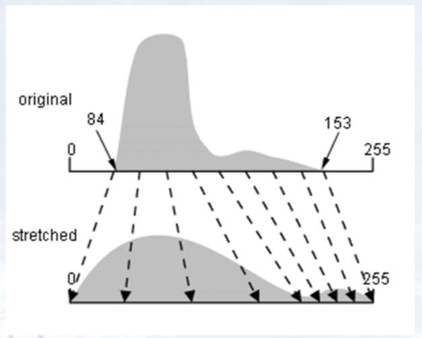

Figure 3: Contrast Streching from [84-153] range to [0-255]

Figure 4: A self explanatory process.

In some cases, a piece-wise linear transformation function can also be created to achieve contrast stretching (as shown in Figure 5) in which a human expert selects two points (r1,s1) and (r2,s2) manually to enhance contrast of the image. The values of both points can also be automatically calculated using some predefined percentage of the available histogram! (e.g. 20% dark, 60% middle and 20% light gray-levels).

**HINT: you can use CDF values to calculate the predefined percentages.**

Figure 5: Contrast Stretching using piece-wise linear transformation function.

## Histogram Equalization:

Histogram equalization is a method in image processing of contrast adjustment using the image's histogram. Histograms of an image before and after equalization. Some important points about the exercise.

* You should apply histogram equalization on any Grayscale image.
* You should not use the built in histogram equalization method available in python or OpenCV
* You should use the formula mentioned below to implement the histogram equalization.

**Histogram sudo code**

I = imread('rain.jpg');

G = rgb2gray(I);

[x,y] =shape(G);

H = zeros(1,256);

for i=1:x

for j=1:y

H(G(i,j)) = H(G(i,j)) + 1;

end

end

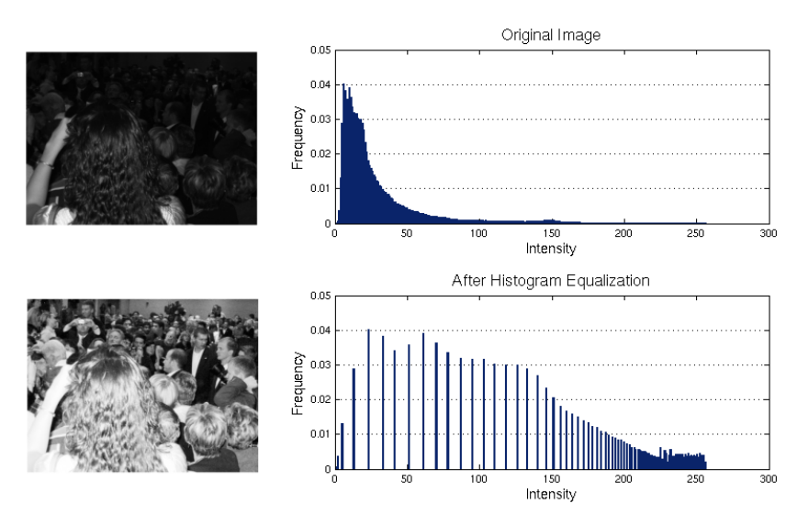

## Lab Tasks:

## Task 1:

1. Load a low contrast image “wiki.jpg”
2. Create an algorithm which applies contrast stretching (pick any implementation you like i.e. either formula or points based)
   1. **NOTE:** For now, you can select the stretching limits by your own.
3. Apply same technique on “lowcon.tif”
4. Summarize your findings on how to extend or automate the task!

***### TASK 1 CODE STARTS HERE ###***

*### TASK 1 CODE ENDS HERE ###*

***### TASK 1 SCREENSHOT STARTS HERE ###***

*### TASK 1 SCREENSHOT ENDS HERE ###*

*### TASK 1 Description*

## Task 2:

1. Write a program that equalizes the histogram of a given image. Consider the formula below

where ‘s’ and ‘r’ are the output and input pixel intensities respectively. ‘L’ is the maximum intensity value (for n bit image L = 2^n). The probability of occurrence of the intensity level rj in the image is approximated by

1. Show the comparison of histograms before and after equalization obtained using:
   1. Your Implementation of the algorithm
   2. OpenCV’s implementation of Histogram Equalization
2. Conclude your findings on following images and analyze the workings of Histogram
   1. dark.tif
   2. bright.tif
   3. lowcon.tif
   4. Wiki.jpg

***### TASK 2 CODE STARTS HERE ###***

*### TASK 2 CODE ENDS HERE ###*

***### TASK 2 SCREENSHOT STARTS HERE ###***

*### TASK 2 SCREENSHOT ENDS HERE ###*

*### TASK 2 Description*

Part 2 Spatial Filtering Basics (Open Ended )

**Task #1: Effect of averaging and the size of averaging filters**

Consider the following image. Apply averaging with a filter size of 3*3, 5*5, 15*15, and 35*35. A sample 3*3 averaging filter is given below.

|  |  |  |
| --- | --- | --- |
| 1 | 1 | 1 |
| 1 | 1 | 1 |
| 1 | 1 | 1 |



1/9 X

What do you observe when increasing the size of the filter and why?

Apply different weighted averaging filters on the same image and note down the effect they have on the input image. One weighted averaging filter is given below.

|  |  |  |
| --- | --- | --- |
| 1 | 2 | 1 |
| 2 | 4 | 2 |
| 1 | 2 | 1 |

1/16 X

**Task #2: Gaussian smoothing**

Apply the following Gaussian filter to the image given above. Here, the σ = 1.4. What impact do you think happen when the value of σ is increased? Don’t forget the normalizing factor while applying the given Gaussian filter.



**Task #3: Un-sharp Masking**

Perform un-sharp masking on the following image. Does this enhance the image? Try with at least two different smoothing methods. How does that affect the results?

**Unsharp masking is a technique to sharpen images, where a blurred version of an image is subtracted from the image itself. The typical blending formula used for unsharp masking is as follows: sharpened = original + (original − blurred) × amount**

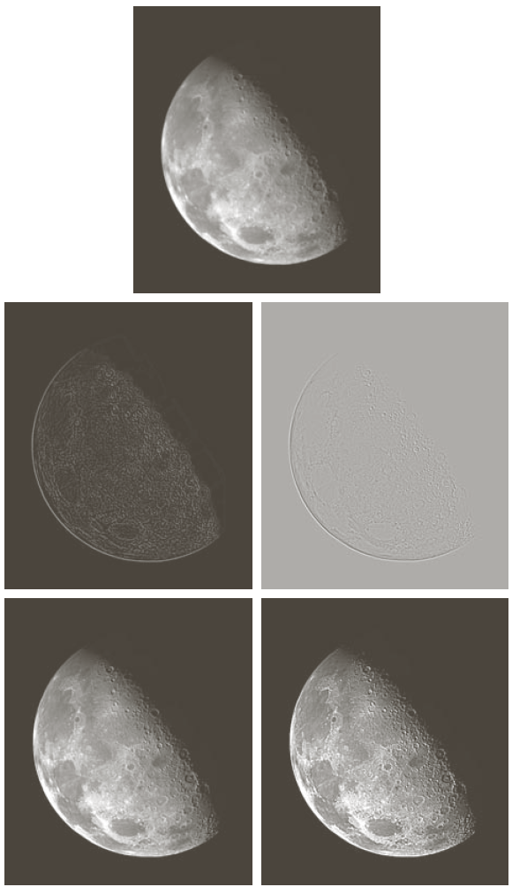

**Task #4: Sharpening filters**

|  |  |
| --- | --- |
| http://www.cs.uregina.ca/Links/class-info/425-nova/Lab3/Exercise/two_cats/two_cats.jpg | http://www.cs.uregina.ca/Links/class-info/425-nova/Lab3/Exercise/two_cats/two_cats_edge.jpg |

Download the following image "[two_cats.jpg](http://www.cs.uregina.ca/Links/class-info/425-nova/Lab3/Exercise/two_cats/two_cats.jpg). (A): Use a spatial filter to get the horizontal edges of the image. (B): Use a spatial filter to get the vertical edges of the image. (C): Add the horizontal edge matrix to the vertical edge matrix to yield the following results (the image on the right).